**Day 3 Lab Coding Challenges**

**Problem 1)**

**Create a Web Page for a AI Division to display information about the AI under the following heads:**

a) What are AI Tools

b) Benefits of AI

c) Best AI tools of 2023

d) AI Video Generators & Editors

e) AI Writing tools and Text generators

Implement the above in a Card Layout with brief shadows for every Card with appropriate images using FLEX and its properties like flex-wrap.

The Sample Output is as shown Below:

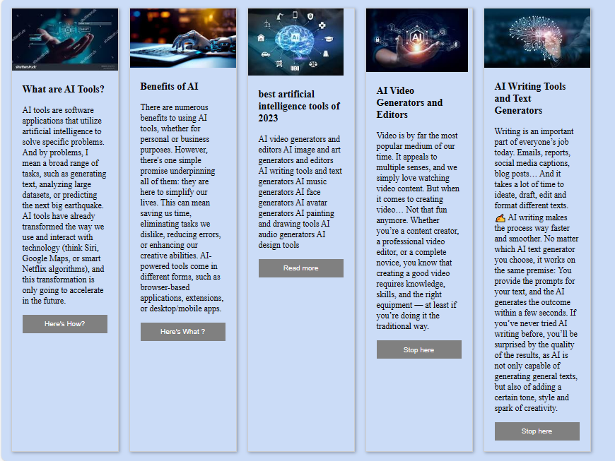

**Problem 2)**

**Create a Web Page for a News Publisher for their online issue,**

Page should show The Images & Corresponding news in the following format using FLEX and its Properties like FLEX Wrap, flex-direction etc.

The Sample Output is as shown below:

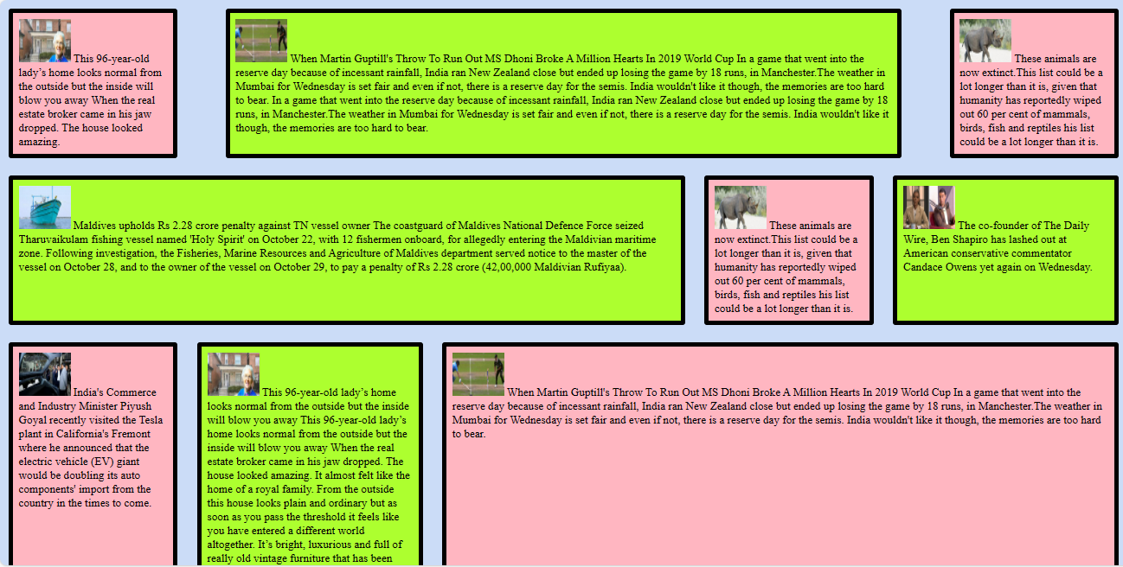

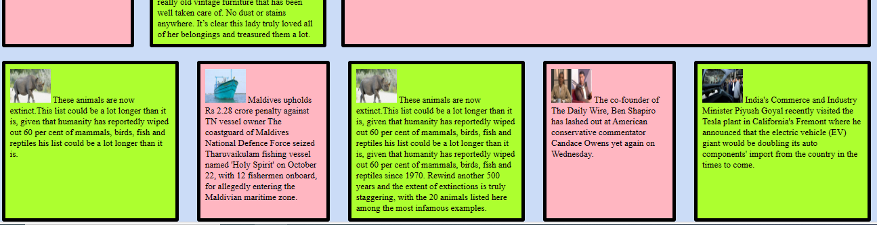

**Problem 3)** **Implement the Content of Problem 1 using GRID since the AI division wants it to be in the GRID format** using grid-template-columns: also try changing it to grid-template-rows and check the output.

**The output for the grid-template-columns should be as shown below.**

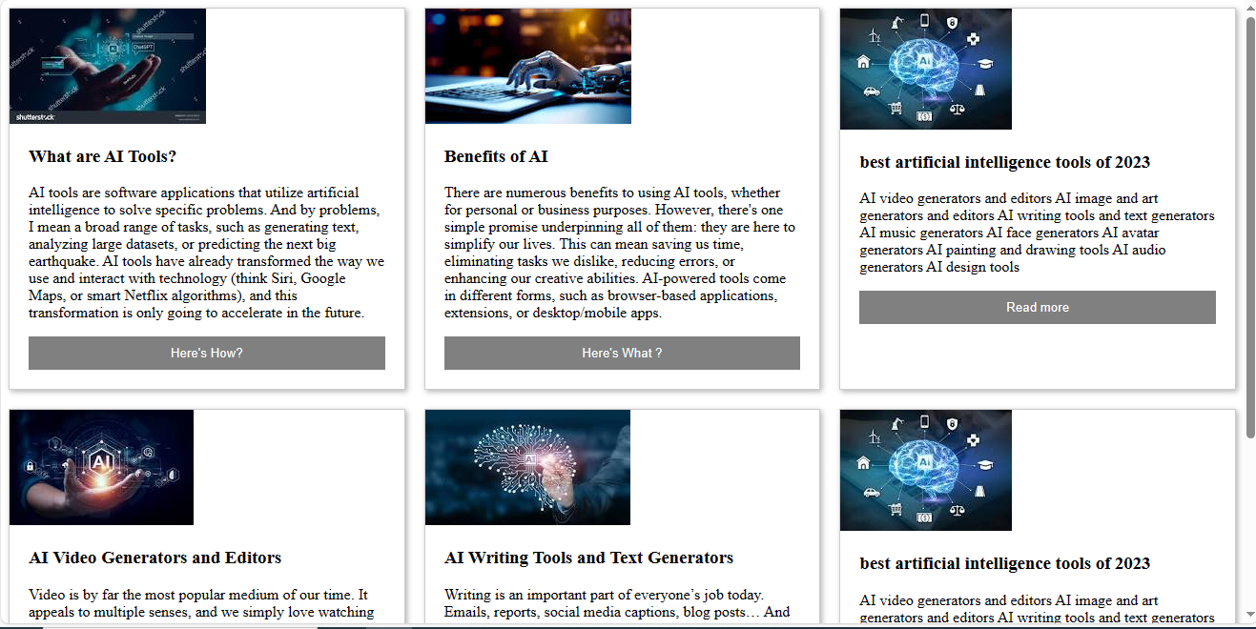

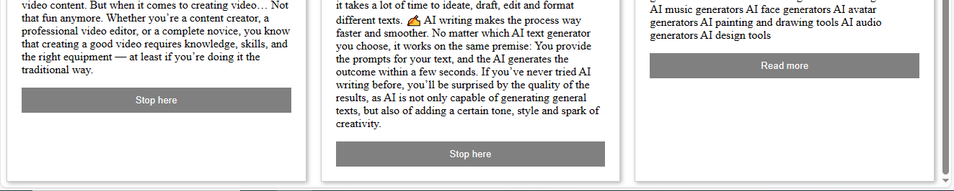

**Problem 4)**

**Create a photo gallery based web page using the GRID and the outputs should be as shown below:**

**Solution : GridDemo2**

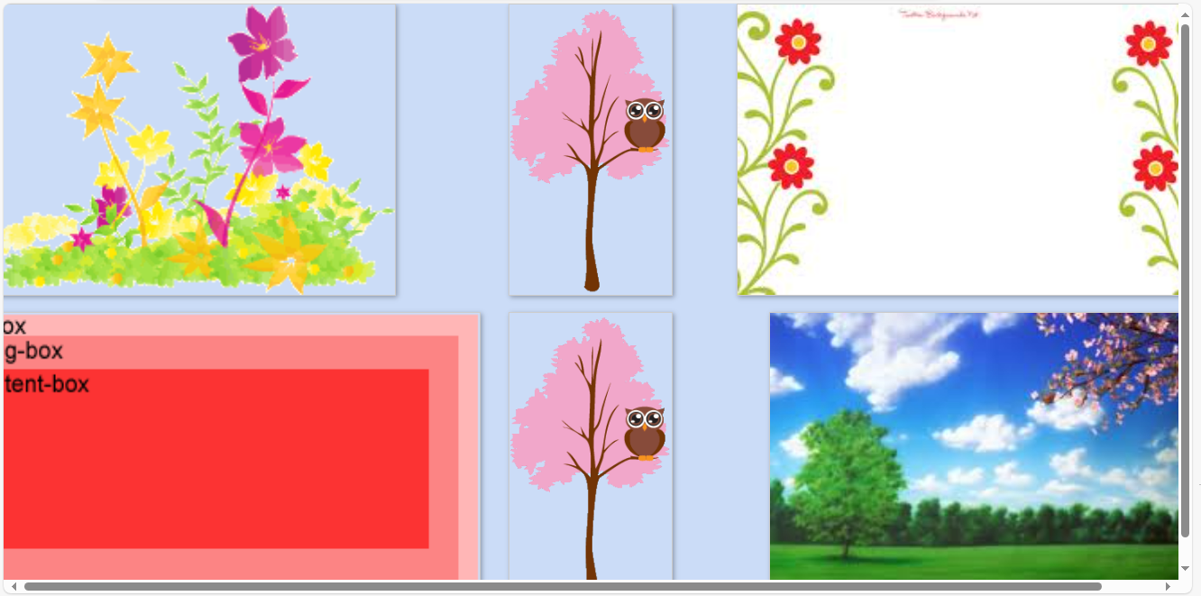

**Solution : GridDemo2a**

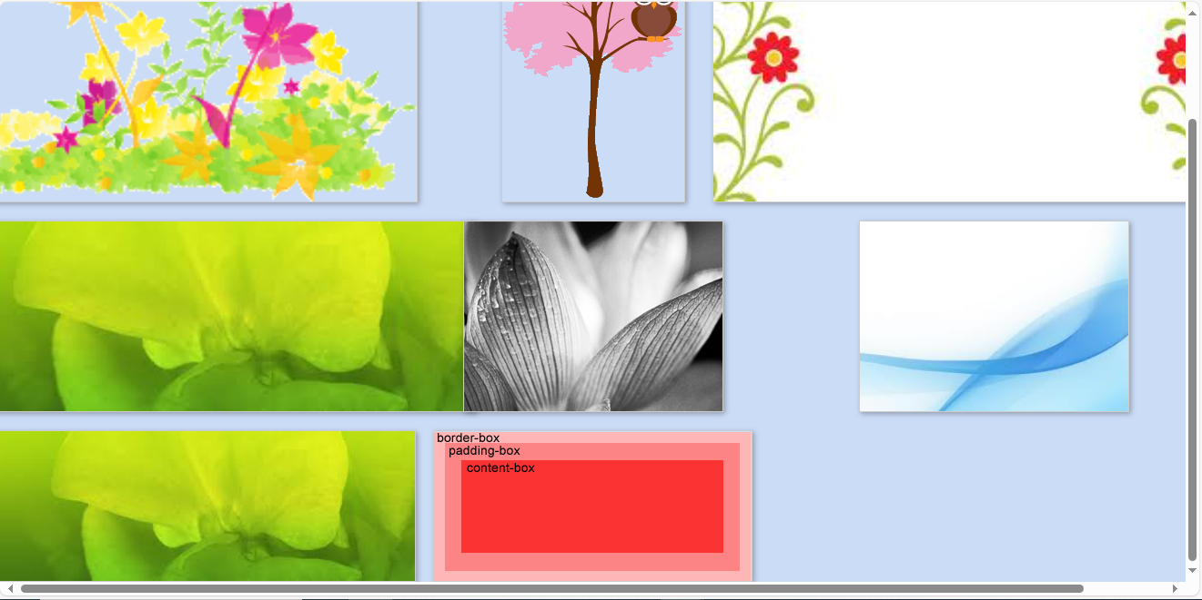

**Solution : GridDemo2b**

